Chapter 1
An algorithm is a sequence of unambiguous instructions for solving a problem, i.e., for obtaining a required output for any legitimate input in a finite amount of time.

- The nonambiguity requirement for each step of an algorithm cannot be compromised.
- The range of inputs for which an algorithm works has to be specified carefully.
- The same algorithm can be represented in several different ways.
- There may exist several algorithms for solving the same problem.
- Algorithms for the same problem can be based on very different ideas and can solve the problem with dramatically different speeds.
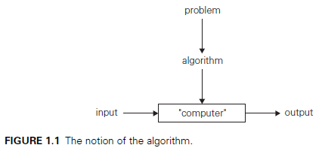
Greatest common divisor of two nonnegative, not-both-zero integers m and n, denoted gcd(m, n), is defined as the largest integer that divides both m and n evenly, i.e., with a remainder of zero. Euclid of Alexandria (third century b.c.) outlined an algorithm for solving this problem.

Euclid’s algorithm is based on applying repeatedly the equality gcd(m, n) = gcd(n, m mod n), where m mod n is the remainder of the division of m by n, until m mod n is equal to 0. Since gcd(m, 0) = m (why?), the last value of m is also the greatest common divisor of the initial m and n.
For example, gcd(60, 24) can be computed as follows:
gcd(60, 24) = gcd(24, 12) = gcd(12, 0) = 12.
Euclid’s algorithm for computing gcd(m, n)
Step 1 If n = 0, return the value of m as the answer and stop; otherwise, proceed to Step 2.
Step 2 Divide m by n and assign the value of the remainder to r.
Step 3 Assign the value of n to m and the value of r to n. Go to Step 1.

Alternatively, we can express the same algorithm in pseudocode:
ALGORITHM Euclid(m, n)
//Computes gcd(m, n) by Euclid’s algorithm
//Input: Two nonnegative, not-both-zero integers m and n
//Output: Greatest common divisor of m and n
while n != 0 do
r ←m mod n
m←n
n←r
return m
The first is simply based on the definition of the greatest common divisor of m and n as the largest integer that divides both numbers evenly.

A common divisor cannot be greater than the smaller of these numbers, which we will denote by t = min{m, n}. So we can start by checking whether t divides both m and n: if it does, t is the answer; if it does not, we simply decrease t by 1 and try again. (How do we know that the process will eventually stop?)
For example, for numbers 60 and 24, the algorithm will try first 24, then 23, and so on, until it reaches 12, where it stops.

Consecutive integer checking algorithm for computing gcd(m, n)
Step 1 Assign the value of min{m, n} to t.
Step 2 Divide m by t. If the remainder of this division is 0, go to Step 3; otherwise, go to Step 4.
Step 3 Divide n by t. If the remainder of this division is 0, return the value of t as the answer and stop; otherwise, proceed to Step 4.
Step 4 Decrease the value of t by 1. Go to Step 2.

Note that unlike Euclid’s algorithm, this algorithm, in the form presented, does not work correctly when one of its input numbers is zero. This example illustrates why it is so important to specify the set of an algorithm’s inputs explicitly and carefully.

The third procedure for finding the greatest common divisor should be familiar to you from middle school.
Middle-school procedure for computing gcd(m, n)
Step 1 Find the prime factors of m.
Step 2 Find the prime factors of n.
Step 3 Identify all the common factors in the two prime expansions found in Step 1 and Step 2. (If p is a common factor occurring p_{m} and p_{n} times in m and n, respectively, it should be repeated min{p_{m}, p_{n}} times.)
Step 4 Compute the product of all the common factors and return it as the greatest common divisor of the numbers given.
Thus, for the numbers 60 and 24, we get
60 = 2 . 2 . 3 . 5
24 = 2 . 2 . 2 . 3
gcd(60, 24) = 2 . 2 . 3 = 12.
The middleschool last procedure is much more complex and slower than Euclid’s algorithm. In addition to inferior efficiency, the middleschool procedure does not qualify, in the form presented, as a legitimate algorithm. Why? Because the prime factorization steps are not defined unambiguously: they require a list of prime numbers.
Incidentally, Step 3 is also not defined clearly enough. Its ambiguity is much easier to rectify than that of the factorization steps, however. How would you find common elements in two sorted lists?

Simple algorithm for generating consecutive primes not exceeding any given integer n > 1. It was probably invented in ancient Greece and is known as the sieve of Eratosthenes (ca. 200 b.c.).

ALGORITHM Sieve(n)
//Implements the sieve of Eratosthenes
//Input: A positive integer n > 1
//Output: Array L of all prime numbers less than or equal to n
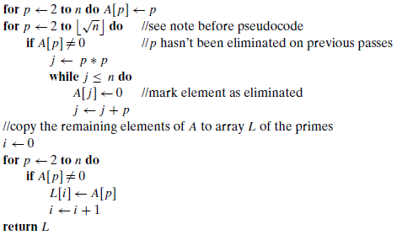
As an example, consider the application of the algorithm to finding the list of primes not exceeding n = 25:
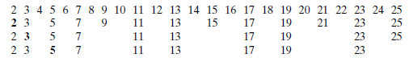
So now we can incorporate the sieve of Eratosthenes into the middle-school procedure to get a legitimate algorithm for computing the greatest common divisor of two positive integers. Note that special care needs to be exercised if one or both input numbers are equal to 1: because mathematicians do not consider 1 to be a prime number, strictly speaking, the method does not work for such inputs.

